Technical Design Document

Selection Toolkit Application

Revision History

|  |  |  |  |  |
| --- | --- | --- | --- | --- |
| Date | Status | Version | Description | Author |
| 2016-14-06 | Draft | 1.0 | Draft version of Technical Design | M. Salmenautio |
| 2016-17-06 | Draft | 1.1 | Section production deployment updated. | M.Salmenautio |
| 2016-20-06 | Draft | 1.2 | Chapter 3.2 added | M.Salmenautio |
| 2016-22-06 | Draft | 1.3 | Chapter 3.3 added | M.Salmenautio |

Table of Contents

1 Introduction 4

2 Selection Toolkit application 4

2.1 Roles and security 4

2.1.1 Roles 4

2.1.2 Security and role hierarchy 5

2.2 Profiles and permission sets 6

2.2.1 HR Business Partner 6

2.2.2 Interviewer profile 7

2.2.3 Permission sets 9

2.3 Questions 9

2.4 Scoring 9

2.5 Anchors 10

2.6 Datamodel 10

2.6.1 Candidate 11

2.6.2 Position 13

2.6.3 Application 14

2.6.4 Interview 14

2.6.5 Question 18

2.6.6 Anchor 20

2.7 Triggers 21

2.8 Process Builder workflow 21

2.9 Visualforce page and controller 24

2.9.1 Visualforce page 24

2.9.2 Controller 24

3 Production deployment 25

3.1 Organization Wide Defaults 25

3.2 Activate Process Builder flow 26

3.3 Dataload 26

4 Glossary 26

5 References & Attachments 26

# Introduction

This document contains the technical design details of the selection toolkit application.

This application is used for tracking and scoring the candidate interviews for AB InBev.

# Selection Toolkit application

## Roles and security

### Roles

Following roles has been identified.

* HR Business Partner
* Interviewer
* Administrator

HR Business Partner is role who owns and runs the hiring process. HR business partner should be able to:

* Create Candidate, Position and application records
* Create interview records for the interviewer
* See all the interviews
* See summary information from each of the interviews
* Add CV as attachment to candidate record
* Add new questions and anchors

Interviewer role conducts the actual interviews. Interviewer should be able to:

* See candidates CV
* See notes from previous interviews
* Conduct interviews
* Do scoring of the candidate
* Update notes
* No changes to interview record is allowed after interview has been compated.

Interviewer should be able to see only his / her own records. Interviewer should not be able to see other interviewer’s records.

### Security and role hierarchy

Selection toolkit application has following organization wide default settings:

* Candidate: Private
* Interview: Private
* Position: Public Read Only
* Application: Controlled by owner
* Anchor: Public Read Only
* Question: Public Read Only

Following role hierarchy has been defined for the application:

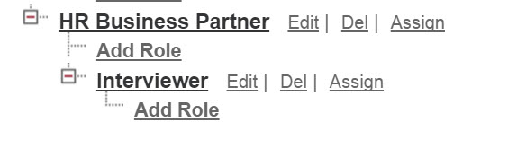

HR Business Partner role is able to see all the interviewer records. HR Business partner is able to see records which are owned by other HR Business Partner role. Following sharing rules has been defined for candidate and position objects.

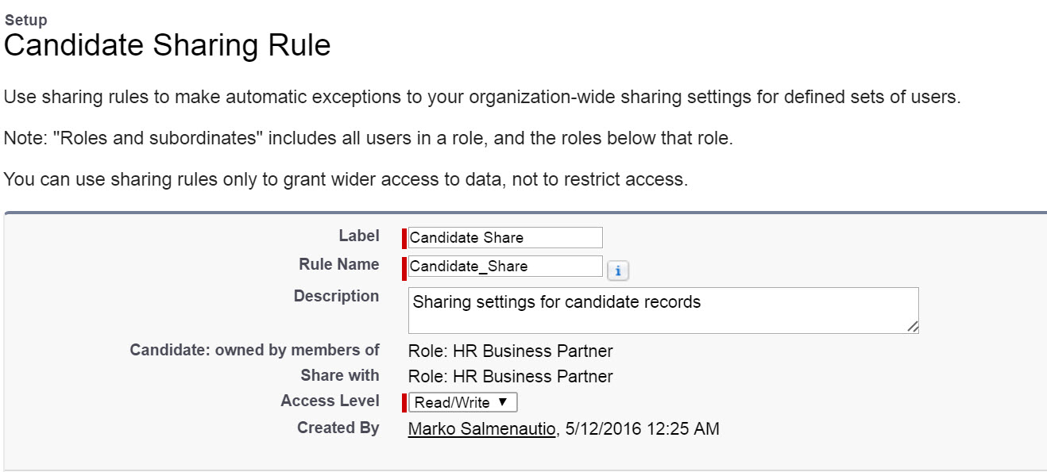

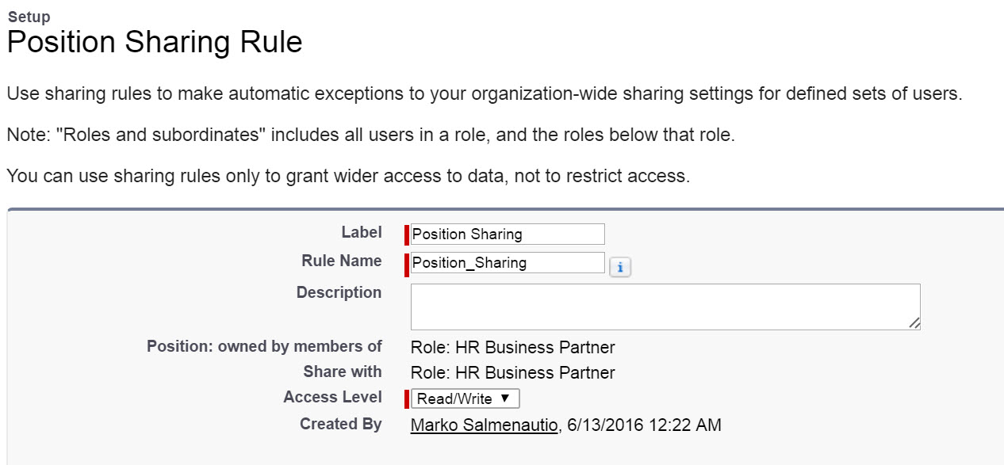

## Profiles and permission sets

Following profiles has been created for selection toolkit application.

* HR Business Partner
* Interviewer

### HR Business Partner

Following pictures illustrates what access rights HR Business Partner profile has.

Tab Settings for selection toolkit application:

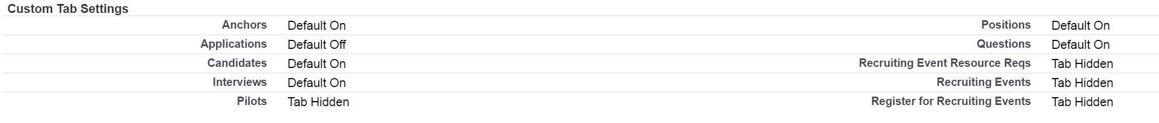

Custom object permissions:

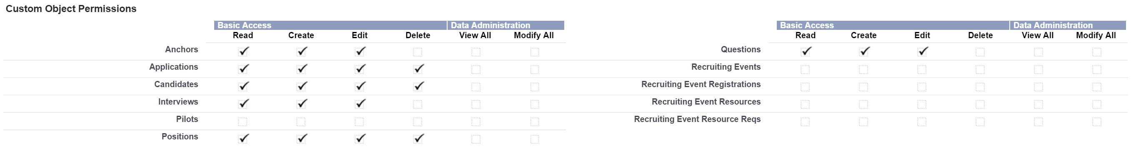

Custom Application settings

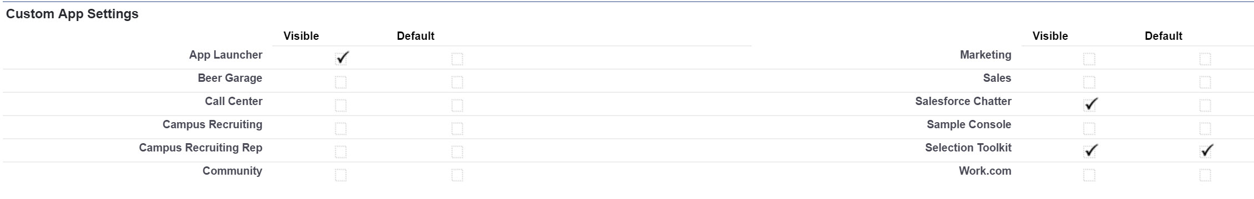

Following apex classes and visualforce pages has been added to the profile:

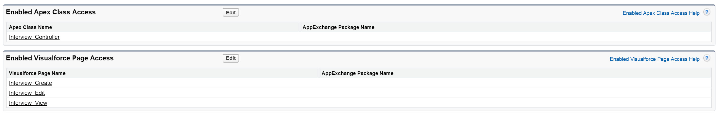

### Interviewer profile

Interviewer profile has following permissions.

Interviewer has following access rights to candidate and position records if record is shared to interviewer.

Candidate object:

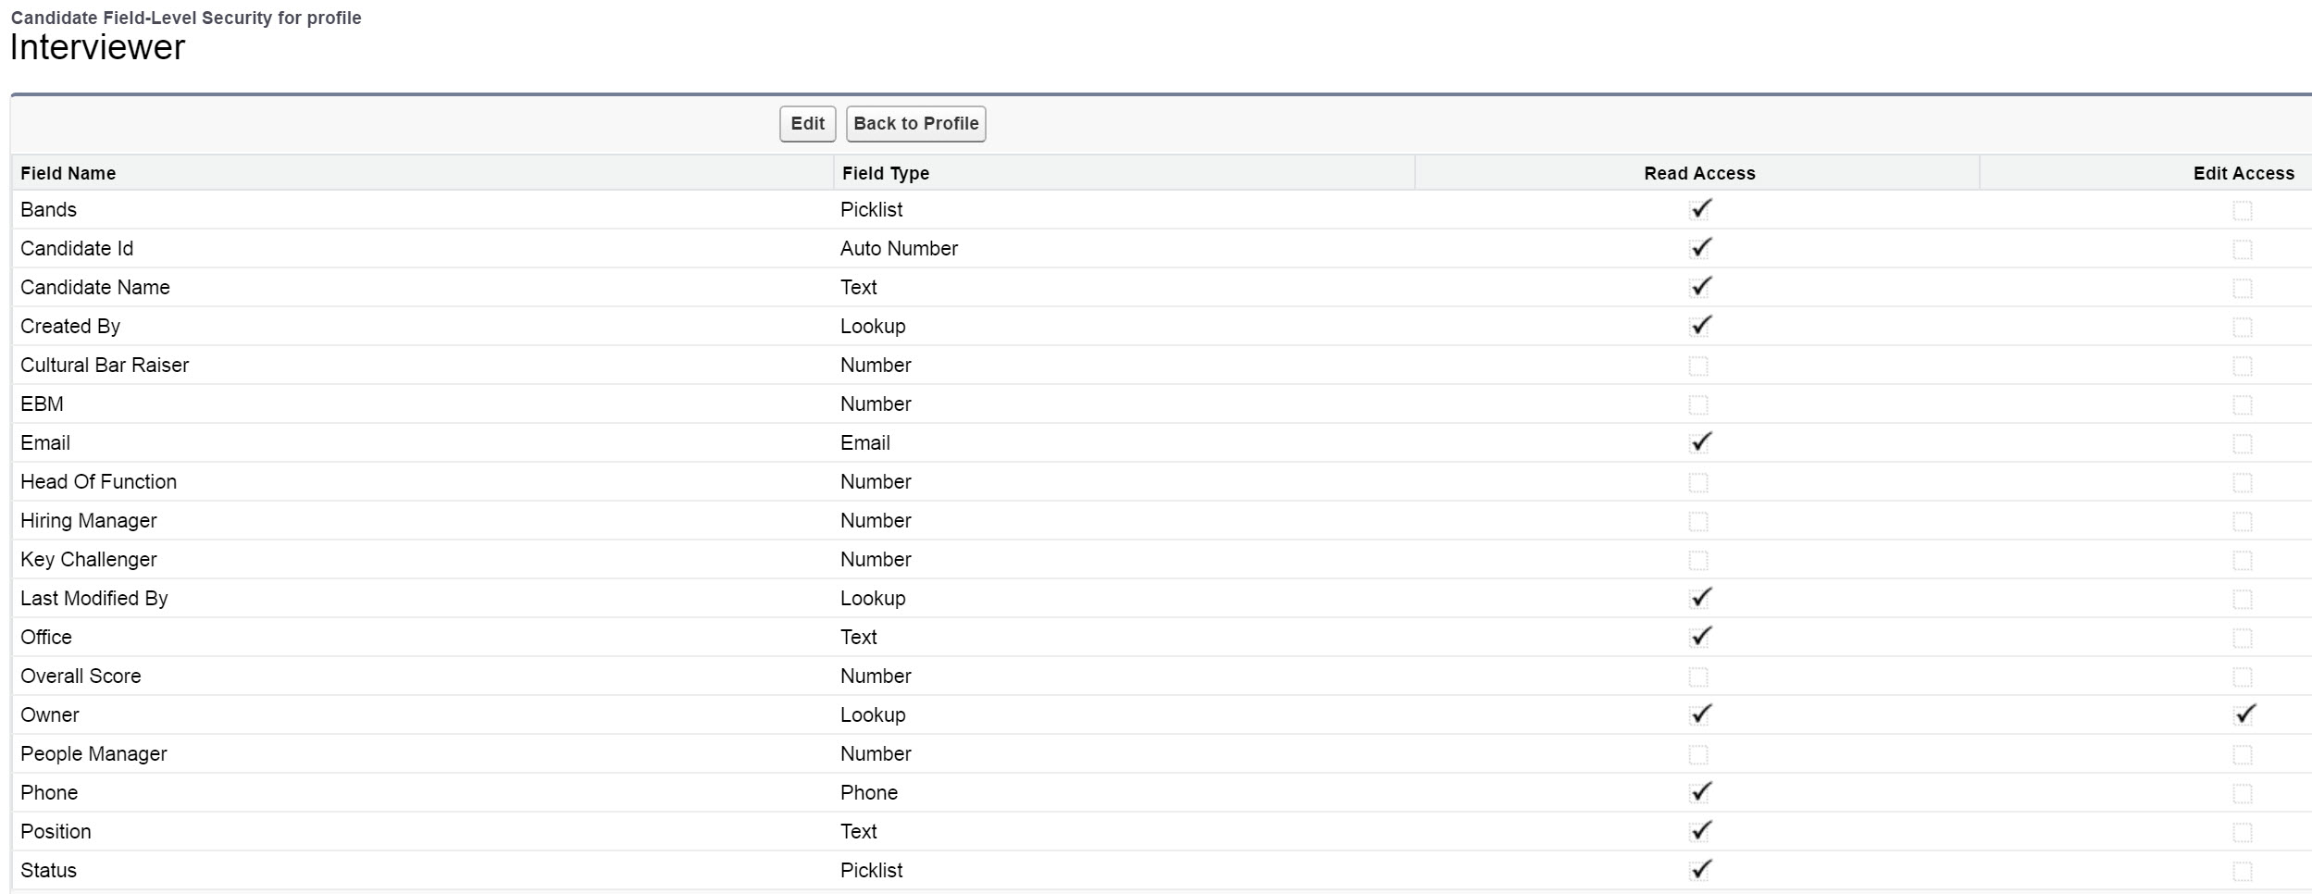

Position object:

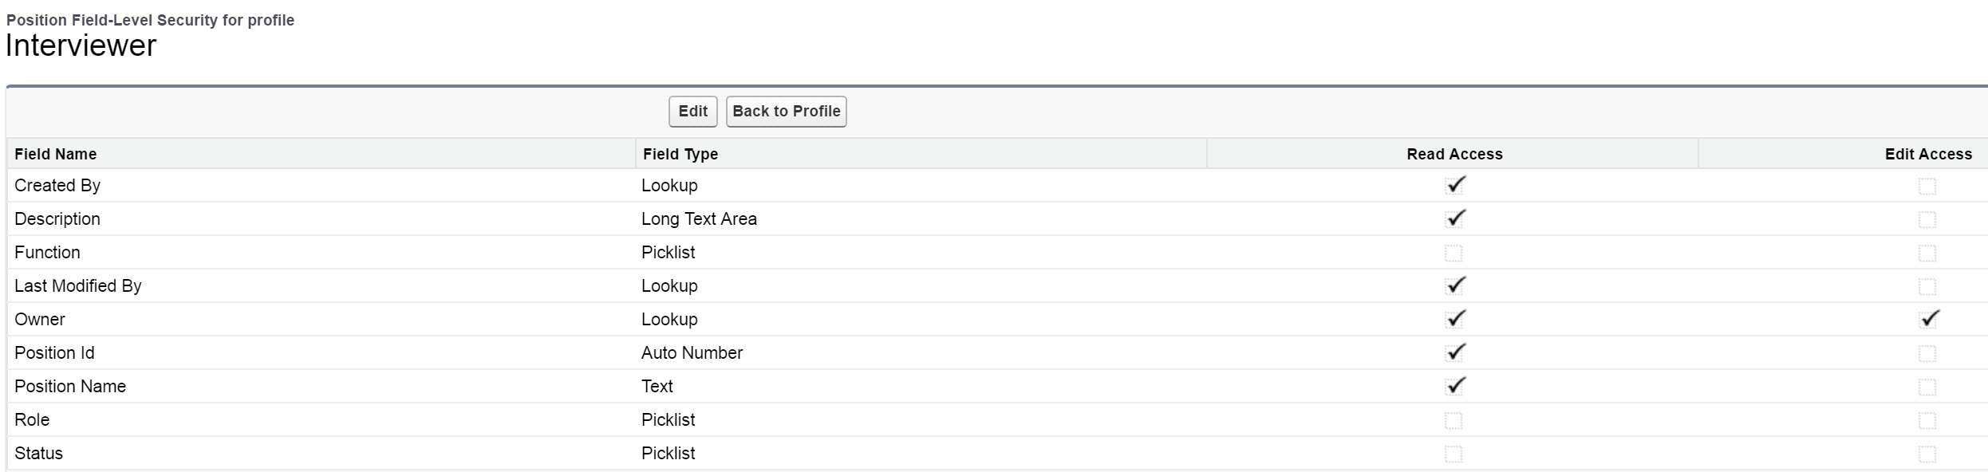

Interviewer has following access rights to selection toolkit objects:

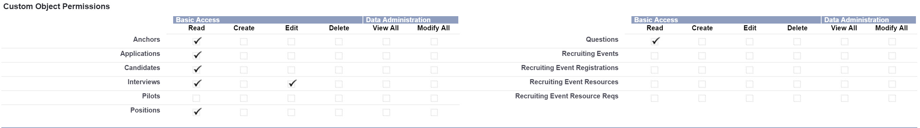

Interviewer can see following tabs:

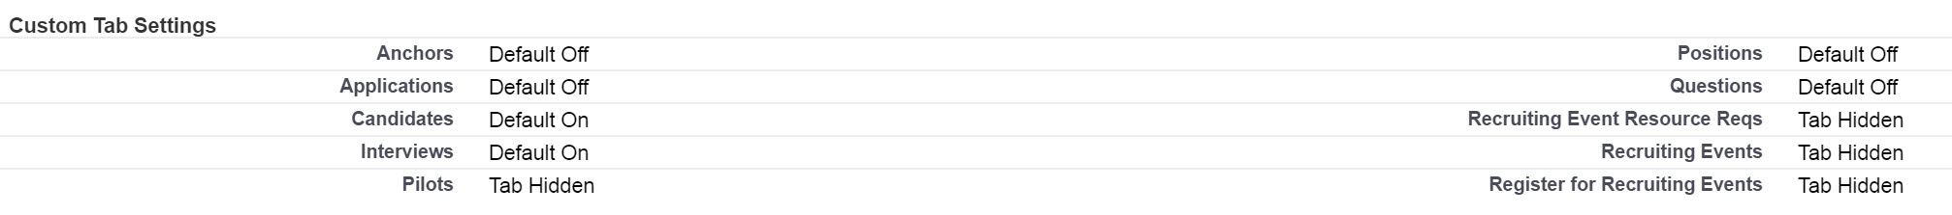

Following apex classes and visualforce pages has been added to the profile:



### Permission sets

Two permission sets has been defined. Name of the permission sets are:

* Selection Toolkit HR Business Partner
* Selection Toolkit Interviewer

These will give same access rights as previously described.

## Questions

Interviewers has a set of predefined questions. Interviewers can ask questions from pre-defined question list or they can ask another question. Only one question per competency area will be asked.

Selection toolkit application has an object where the questions can be maintained. HR Business Partner and Administrator can maintain the questions. New questions can be added and old questions can be deactivated.

## Scoring

Candidates will be scored based on the answers. Scoring will be given for each of the competency area. Scoring is from 1-9 and scoring has been divided to three areas. The scoring areas are following:

* Unfavorable: 1-3
* Acceptable: 4-6
* Favorable: 7-9

For each of the assessor an overall scoring will be calculated. This will be the average of competency area scoring. Also at candidate level the overall scoring is calculated. This will be the average of different interviews.

For each of the areas there are anchors which are described at next chapter.

## Anchors

For each of the competencies there are pre-defined anchors. Anchors are divided per score area. Section 3.2 describe the scoring areas.

HR Business Partner and Administrator can add new anchors and deactivate old anchors.

## Datamodel

Based on the requirements following data model has been defined.

Application will include 4 different objects which are:

* Candidate
* Position
* Application
* Interviews
* Questions
* Anchors

Following picture illustrates the datamodel.

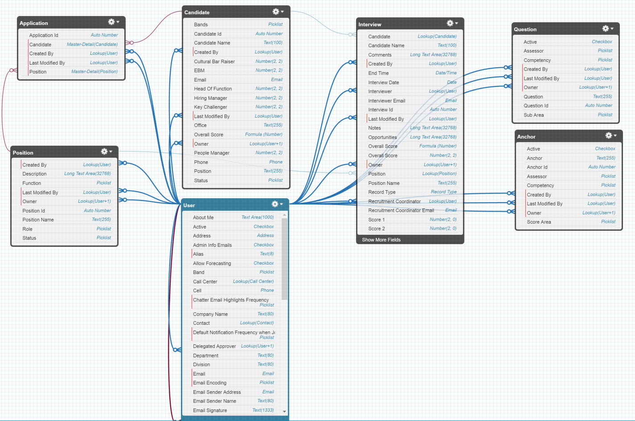

### Candidate

Candidate object will include information about the candidate. Here are the details of the candidate object.

Object Name: Candidate

API Name: Candidate__c

Optional Features: Allow Reports

Allow Activities

Track Field History

Allow in chatter groups

Allow Search

Fields:

|  |  |  |  |
| --- | --- | --- | --- |
| Field | API Name | Field Type | Values |
| Id |  | Number | CAN- {000000001} |
| Candidate Name |  | Text(80) |  |
| Created By |  | Lookup(User) |  |
| Last Modifyed By |  | Lookup(User) |  |
| Owner |  | Lookup(User,Queue) |  |
| Email | Email__c | Email |  |
| Phone | Phone__c | Phone |  |
| Office | Office__c | Text(255) |  |
| Position | Position__c | Text(255) |  |
| Status | Status__c | Picklist | Application Open |
|  |  |  | People Manager Interview |
|  |  |  | Hiring Manager Interview |
|  |  |  | Key Challenger Interview |
|  |  |  | Cultural Bar Raiser Interview |
|  |  |  | Head of Function Interview |
|  |  |  | EBM Interview |
|  |  |  | Candidate Hired |
|  |  |  | Candidate Did Not Pass |
| Bands | Bands__c | Picklist | EBM |
|  |  |  | 0 |
|  |  |  | I-A |
|  |  |  | I-B |
|  |  |  | II-A |
|  |  |  | II-B |
|  |  |  | III-A |
|  |  |  | III-B |
|  |  |  | IV-A |
|  |  |  | IV-B |
|  |  |  | V-A |
|  |  |  | V-B |
|  |  |  | VI-A |
|  |  |  | VI-B |
|  |  |  | VII-A |
|  |  |  | VII-B |

### Position

Position object contains information about different position. Candidate will apply for the position. Position object contains following field.

|  |  |  |  |
| --- | --- | --- | --- |
| Field | API Name | Field Type | Values |
| Position Id | Name | Auto Number | POS-{000000} |
| Positon Name | Position_Name__c | Text(255) |  |
| Created By |  | Lookup(User) |  |
| Last Modifyed By |  | Lookup(User) |  |
| Owner |  | Lookup(User,Queue) |  |
| Description | Description__c | Long Text Area |  |
| Function | Function__c | Picklist | DGO |
|  |  |  | Finance |
|  |  |  | IBS |
|  |  |  | Legal / CA |
|  |  |  | Marketing |
|  |  |  | People |
|  |  |  | Procurement |
|  |  |  | Sales |
|  |  |  | Supply |
| Role | Role__c | Picklist | Manager |
|  |  |  | Director |
|  |  |  | VP |
| Status | Status__C | Picklist | Open |
|  |  |  | Closed |

### Application

Application object is a junction object between position and candidate. Candidate will apply to the position by using a application. Application object has a master detail relation to position and candidate object.

Application object contains following fields:

|  |  |  |  |
| --- | --- | --- | --- |
| Field | API Name | Field Type | Values |
| Application Id | Name | Auto Number | APPL-{000000} |
| Created By |  | Lookup(User) |  |
| Last Modifyed By |  | Lookup(User) |  |
| Candidate | Candidate__c | Master - Detail |  |
| Position | Position__C | Master – Detail |  |

### Interview

Interview object contains interview records. Interviews consist from different areas (Assessors). Each of these has different set of competencies and questions/ anchors. Each of the areas will have their own record type. Interview record will have following record types:

* People Manager
* Hiring Manager
* Key Challenger
* Cultural Bar Raiser
* Head of functions
* EBM

Competencies are related to interview areas (Assessors). Following table shows competencies per assessor.

|  |  |
| --- | --- |
| Assessor | Competency |
| People Manager | Introduction |
|  | Dream Big |
|  | Develop People |
|  | Interest And Ambition |
| Hiring Manager | Introduction |
|  | Functional Achievements |
| Key Challenger | Introduction |
|  | Industry Knowledge |
|  | Socio Economic |
|  | Connecting Dots |
|  | Functional Challenge |
| Cultural Bar Raiser | Introduction |
|  | Dream Big |
|  | Develop People |
|  | Live Our Culture |
| Head Of Functions | Introduction |
|  | Insights |
|  | Dream Big |
|  | Develop People |
|  | Live Our Culture |
| EBM | Introduction |
|  | Dream Big |
|  | Develop People |
|  | Live Our Culture |

Interviewer can score each of the competency areas (except introduction). Value of the scoring is from 1 to 9. Values are divided to three areas, which are

* Unfavorable, scores 1-3
* Acceptable, scores 4-6
* Favorable, scores 7-9

Overall score is an average of competency scores.

Interviewer record will contain following fields:

|  |  |  |  |  |
| --- | --- | --- | --- | --- |
| Field Name | API Name | Field Type | Purpose | Values |
| RecordType | RecordType | RecordType | Assessor of the interview |  |
| Owner | Owner | Owner | Interviewer will be the record owner |  |
| Created By | CreatedBy | Lookup(user) | Who created the record |  |
| Last Modifyed By | LastModifyedBy | Lookup(user) | Who modified the record |  |
| Candidate | Candidate__c | Lookup(candidate) | Id of the candidate |  |
| Candidate Name | Candidate_Name__c | Text(100) | Name of the candidate |  |
| Interviewer | Interviewer__c | Lookup(user) | Name of the interviewer |  |
| Interview Email | Interview_Email__c | Email | Email of the interviewer |  |
| Recruiment Coordinator | Recruitment_coordinator__c | Lookup(user) | Name of the recruitment coordinator |  |
| Recruiment Coordinator Email | Recruiment_coordinator_email__c | Email | Email of the recruitment coordinator |  |
| Status | Status__c | Picklist | Status of the interview | Open, Completed |
| Interview Date | Interview_date__c | Date | Date when interview was conducted |  |
| Selected Question 1 | Selected_question_1 | Text(20) | Which question was selected for competency |  |
| Selected Question 2 | Selected_question_2 | Text(20) | Which question was selected for competency |  |
| Selected Question 3 | Selected_question_3 | Text(20) | Which question was selected for competency |  |
| Selected Question 4 | Selected_question_4 | Text(20) | Which question was selected for competency |  |
| Selected Anchors | Selected_anchors__c | Text(1000) | Which anchors were selected |  |
| Score 1 | Score_1__c | Number (2,0) | Score for competency |  |
| Score 2 | Score_2__c | Number (2,0) | Score for competency |  |
| Score 3 | Score_3__c | Number (2,0) | Score for competency |  |
| Score 4 | Score_4__c | Number (2,0) | Score for competency |  |
| Overall Score | Overall_score__c | Number | Overall Score |  |
| Notes | Notes__c | Long Text Area | Notes of the interview |  |
| Comments | Comments__c | Long Text Area | Comments for the interviewer |  |
| Opportunities | Opportunities__c | Long Text Area | Opportunities |  |
| Strenghts | Strengths__c | Long Text Area | Strenghts |  |

### Question

Question object contains all the pre-defined questions. Questions will be maintained by administrator.

Object Name: Question

API Name: Question__c

Optional Features: Allow Reports

Allow Activities

Track Field History

Allow in chatter groups

Allow Search

Fields:

|  |  |  |  |
| --- | --- | --- | --- |
| Field | API Name | Field Type | Values |
| Question Id | Name | Autonumber | Q-{0000} |
| Created By |  | Lookup(User) |  |
| Last Modifyed By |  | Lookup(User) |  |
| Owner |  | Lookup(User,Queue) |  |
| Active | Active__c | Checkbox |  |
| Assessor | Assessor__c | Picklist | People Manager |
|  |  |  | Hiring Manager |
|  |  |  | Key Challenger |
|  |  |  | Cultural Bar Raiser |
|  |  |  | Head Of Function |
|  |  |  | EBM |
| Competency | Competency__c | Picklist | Introduction |
|  |  |  | Dream Big |
|  |  |  | Develop People |
|  |  |  | Live Our Culture |
|  |  |  | Interest And Ambition |
|  |  |  | Functional Achievement |
|  |  |  | Industry Knowledge |
|  |  |  | Socio Economic |
|  |  |  | Connecting The Dots |
|  |  |  | Funcional Challange |
| Question | Question__c | Text(255) |  |
| Sub Area | Sub_area__c | Picklist | Lead |
|  |  |  | Option 1 |
|  |  |  | Option 2 |
|  |  |  | Option 3 |
|  |  |  | Option 4 |
|  |  |  | Option 5 |
|  |  |  | Option 6 |

### Anchor

Anchor object contains all the pre-defined anchors. Anchors will be maintained by administrator

Object Name: Anchor

API Name: anchor__c

Optional Features: Allow Reports

Allow Activities

Track Field History

Allow in chatter groups

Allow Search

|  |  |  |  |
| --- | --- | --- | --- |
| Field | API Name | Field Type | Values |
| Anchor Id | Name | Autonumber | ANC-{0000} |
| Created By |  | Lookup(User) |  |
| Last Modifyed By |  | Lookup(User) |  |
| Owner |  | Lookup(User,Queue) |  |
| Active | Active__c | Checkbox |  |
| Assessor | Assessor__c | Picklist | People Manager |
|  |  |  | Hiring Manager |
|  |  |  | Key Challenger |
|  |  |  | Cultural Bar Raiser |
|  |  |  | Head Of Function |
|  |  |  | EBM |
| Competency | Competency__c | Picklist | Introduction |
|  |  |  | Dream Big |
|  |  |  | Develop People |
|  |  |  | Live Our Culture |
|  |  |  | Interest And Ambition |
|  |  |  | Functional Achievement |
|  |  |  | Industry Knowledge |
|  |  |  | Socio Economic |
|  |  |  | Connecting The Dots |
|  |  |  | Funcional Challange |
| Anchor | Anchor__c | Text(255) |  |
| Score Area | Score_area__c | Picklist | Unfavorable, Acceptable, Favorable |

## Triggers

Interview object has a trigger when record is created. Following activities will happen before and after record has been added.

Before Trigger:

* Owner of the record will be set to interviewer
* Record status is set to “Open”
* Name of the candidate will be set
* Name of the position will be set

After Trigger:

* The status of the candidate record will be set according to the type of the interview record

## Process Builder workflow

An email notification will be sent to the interviewer and recruitment coordinator when interview record has been created. Notification is sent by using a process builder workflow.

Following process builder workflow has been added.

Name of the process: Selection Toolkit Send Email Notification

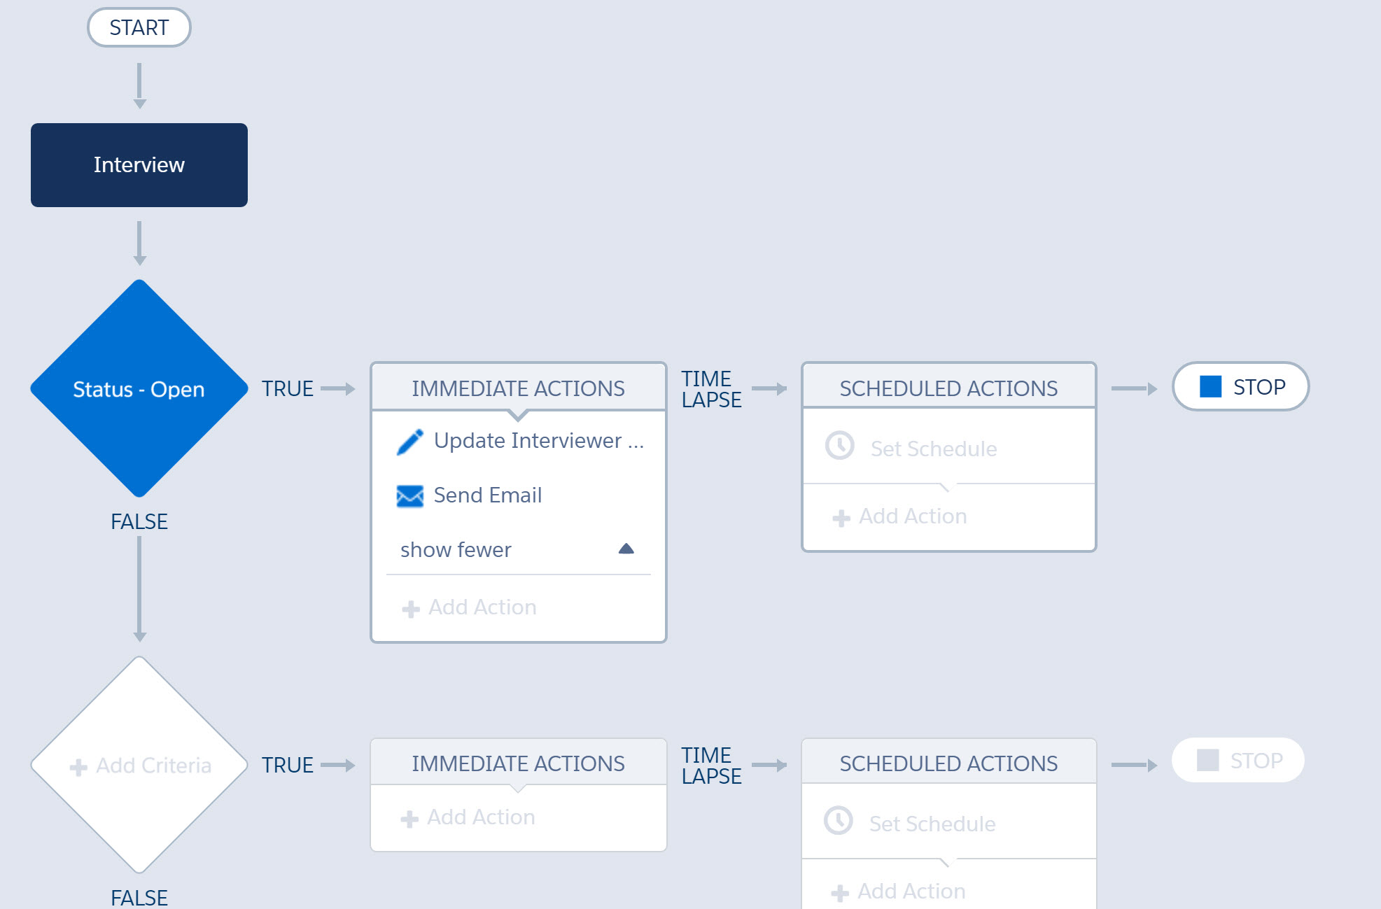

Process will do following steps:

* Process is executed when interview record is created and Status has value “Open”
* Process will update fields interviewer email and recruiter coordinator email
* Process will send email by using email alert “Selection Toolkit Send Email Notification”

Notification has following configuration:

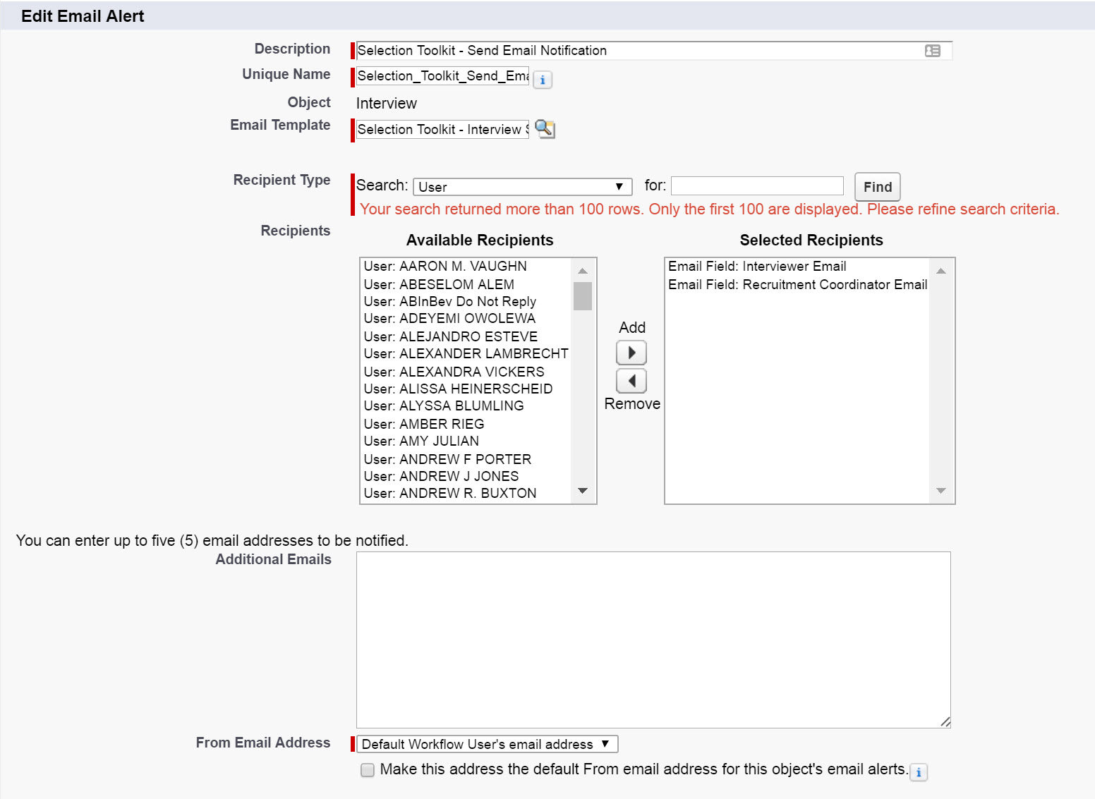

Notification is using email template “Selection Toolkit – Interview Scheduled”

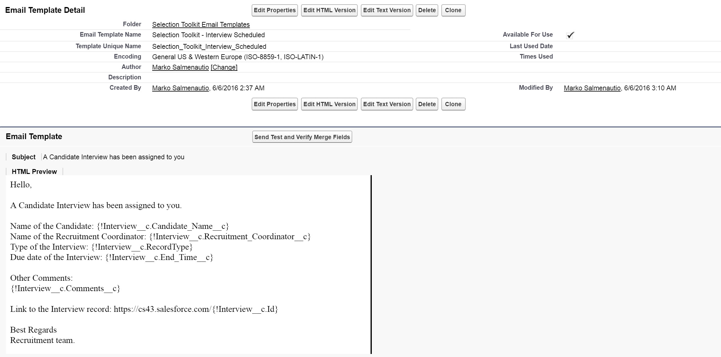

## Visualforce page and controller

### Visualforce page

There are two visuarforce pages interview_create and interview_view. Interview_create page is used for creating an interview record. Interview_view page is used when interviewer is conducting the interview.

Interview_view page has two modes, which are view and edit. Interview page works in following way:

1. When you open an interview record which status is “Open” it’s possible to start the interview by selecting “Start Interview”.
2. When you open interview record which status is “Completed” it’s only possible to view the record.
3. When you start your interview you have two options. You can save the record by selecting “Save For Later”. This will only save the record and the status of the record will stay “Open”.
4. When you select “Submit” it will save the record and set status to “Completed”.
5. When status is set to “Completed” it’s not possible to edit the record any more.
6. Interview_view page contains some required fields:
   1. Notes, Opportunitues and strengths field should contain 150 characters
7. If an attachment is uploaded for the candidate it will be visible under “Canidate CV”

### Controller

The name of the visualforce controller is “Interview_controller”. Controller consumes data from others objects like questions and achors and shows the data at visualforce page.

Visualforce page has custom settings. The name of the custom settings object is “Interview_Section_Settings__c” and “Textarea_Minimum_Chars__c”. Interview section settings object contains following information:

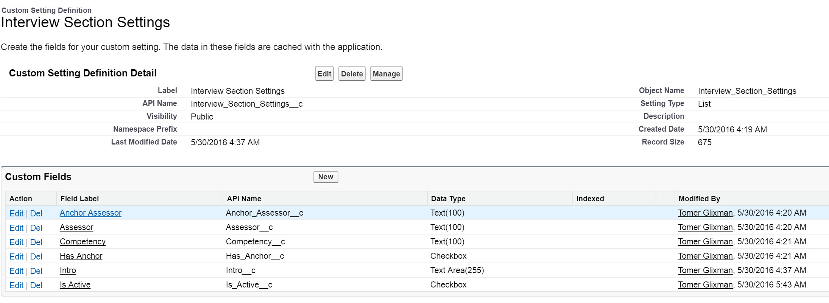

By using the information stored to object visualforce page is able to select correct questions and anchors to each interview type.

Textarea Minimum Chars object contains following information.

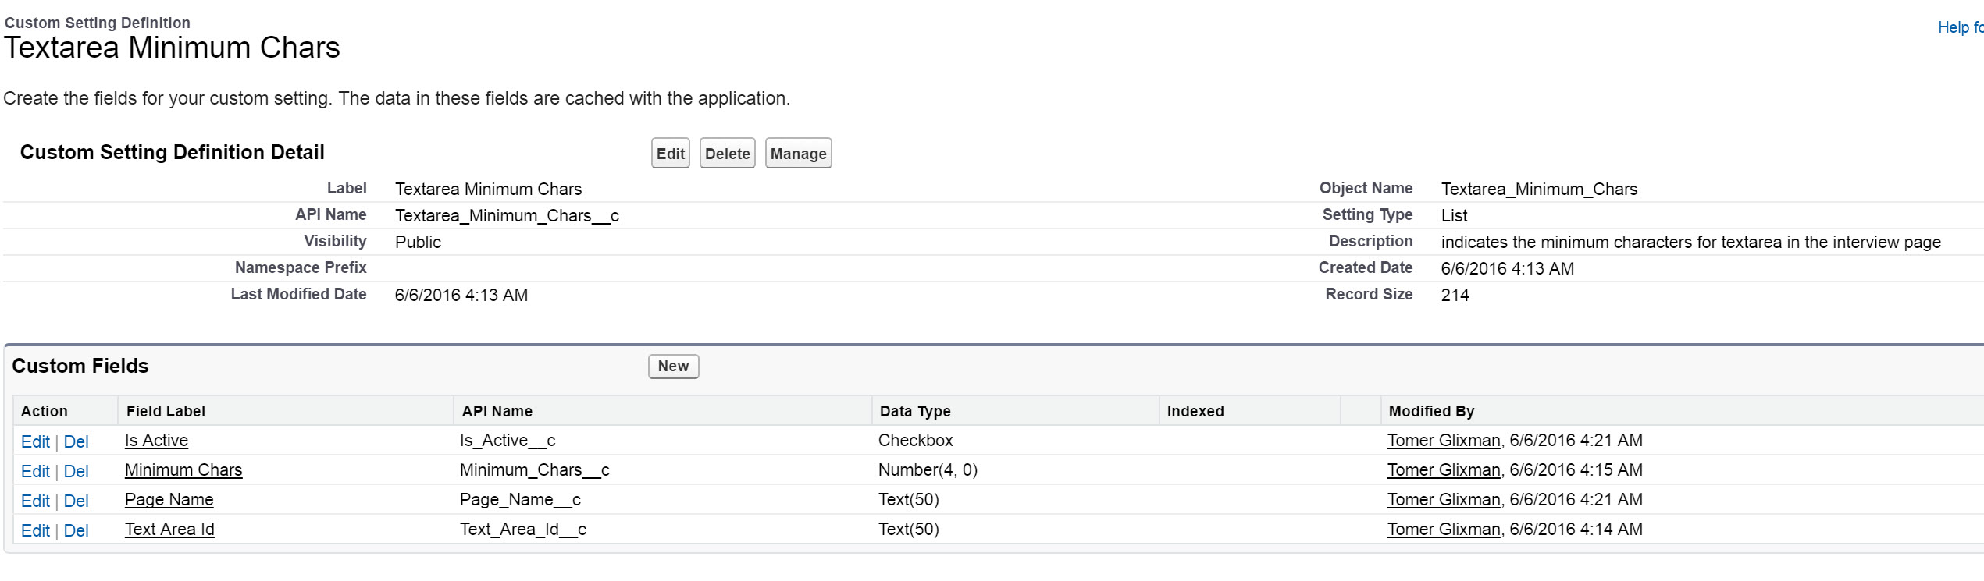

This object define how many characters there should be at certain fields.

# Production deployment

Production deployment will happen by using ANT migration tool. Ant migration tool contains a package file which has been provided to Infosys.

## Organization Wide Defaults

Selection toolkit application has following organization wide defaults. These needs to be deployed manually after production migration has been deployed by using Ant migration tool.

|  |  |
| --- | --- |
| Object | Access level |
| Anchor | Public Read Only |
| Application | Controlled By Parent |
| Candidate | Private |
| Position | Private |
| Interview | Private |
| Question | Public Read Only |

## Activate Process Builder flow

An email notification will be sent to the interviewer and recruitment coordinator when interview record has been created. Notification is sent by using a process builder workflow.

After configuration has been uploaded to the production environment by using ANT the flow needs to be activated manually.

Activate following process builder flow “Selection Toolkit Send Email Notification”.

## Dataload

All the data from following objects needs to be moved from sandbox environment to production environment:

* Anchor__c
* Question__c
* Textarea_Minimum_Chars__c
* Interview_Section_Settings__c

# Glossary

Below are given definitions of acronyms and terminology used in the SAC.

|  |  |
| --- | --- |
| **Term** | **Definition** |
|  |  |

# References & Attachments

Below are given a list of the products given as input to the SAC document.

|  |  |  |
| --- | --- | --- |
| **Input** | **File name / URL** | **Responsible resource (name)** |
| 1. Assessor Interview Guide_People |  |  |
| 2. Assessor Interview Guide_Hiring Manager |  |  |
| 3. Assessor Interview Guide_Key Challenger |  |  |
| 4. Assessor Interview Guide_Cultural Bar Raiser |  |  |
| 5. Assessor Interview Guide_Head of Function |  |  |
| 6. Assessor Interview Guide_EBM |  |  |